**General Packet Radio Service**

1. **GPRS Architecture**

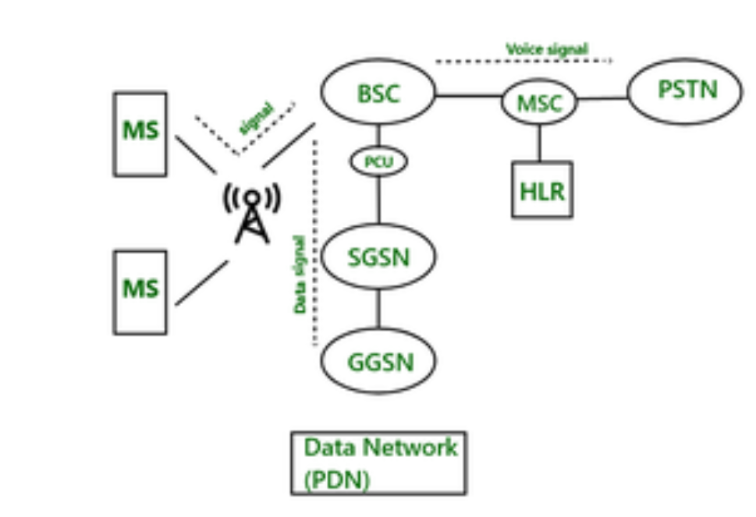

Figure: GPRS Architecture

**Components of GPRS Architecture**

**Mobile Station(MS)**

GPRC requires enhanced mobile stations, as existing mobile stations were designed according to the GSM network, and they were unable in handling enhanced data packets. A variety of high-speed mobile stations are available to support enhanced data packets. These mobile stations are also capable of handling the GSM architecture to make voice calls.

**Base Station Subsystem (BSC)**

In GSM architecture there is one component called BSC. But in GPRS there is one component is added to BSC called PCU. PCU stands for Packet Control Unit. If the signal comes to BSC and that signal contains data, then PCU routes to the SGSN. The interface is used between BSC and PCU is the FRI interface. After the signal comes to SGSN, it delivers the data packet to the GGSN. GGSN routes the data packet to the data network (PDN- Predefined Data Network).

GPRS Support Nodes

GPRS support nodes are of two types:

**1. Serving GPRS Support Node (SGSN)**

It is responsible for the following tasks:

1. Packet Delivery
2. Mobility management
3. Apply/ sign off of terminals
4. Localization
5. LLC (Logical Link Control) management
6. Authentication
7. Billing

**2. Gateway GPRS Support Node (GGSN)**

It is responsible for the following tasks:

1. Mediator between GPRS between backbone and external data networks.
2. Saves current data for the SGSN address of the participant as well as their profile and data for authentication and invoice.

**Internal Backbone Network**

It is an IP-based network that is used to support the working of GPRS and this is responsible to carry new packets between different GSNs. The tunneling is used between SGNSs and GGSNs to exchange information without informing the internal backbone.

**Mobility Support**

GPRS has the following mechanism to support mobility in the network:

1.Attachment Procedure

2. Location and Handoff Management

**Routing Area**

This is similar to the location area in GSM the only difference is routing area use fewer cells as routing areas are smaller than the location area.

**SMS in GSM**

GSM introduced a mechanism of Short Messaging Service(SMS) which is similar to peer-to-peer Instant messaging.

**Features of GPRS**

1. GPRS is a wireless communication service that allows data to be transmitted over a cellular network.
2. GPRS uses packet-switching technology to transmit data, which means that data is divided into small packets and sent over the network in a more efficient way.
3. GPRS offers always-on connectivity, which means that a user can stay connected to the network at all times, without having to establish a connection every time they want to send or receive data.
4. GPRS provides faster data transfer rates compared to the earlier generation of cellular networks, such as GSM.
5. GPRS enables new applications and services to be developed, such as mobile internet browsing and email.
6. GPRS is a precursor to modern cellular data technologies, such as 3G and 4G.

**Function of GPRS**

1. A mobile generation called GPRS is used to talk information via mobile networks.
2. It allows clients to access the internet and different data services on their cell gadgets.
3. Due to its low prices and environmental friendliness, GPRS is a famous option for consumers.

**Advantages of GPRS**

1. A high-speed data transfer cost is offered to mobile devices through General Packet Radio Service or GPRS.
2. Web browsing, email sending and receiving, and online shopping are just a few of the online services that GPRS users can access while they are on the move.
3. Because GPRS is always operational, customers can access the internet quickly and without any problems without utilizing dial-up.
4. GPRS offers a cost-effective approach to transmitting statistics because it only charges for the volume of data transferred, not for the amount of time spent online.
5. GPRS offers users a flexible option because it functions well with a variety of mobile devices.

**Reference:**

[GSM Test GPRS | Arduino](https://www.arduino.cc/en/Tutorial/MKRGSMToolsTestGPRS)

[Arduino GSM Shield | Arduino Documentation](https://docs.arduino.cc/retired/shields/arduino-gsm-shield)